In this project, I created a program that analyzes the Corner Grocer purchase record and counts how often each item appears in the file CS210_Project_Three_Input_File.txt. The program allows the user to search for an item, print all item frequencies, or display a histogram. A backup file named frequency.dat is automatically created at startup to preserve the results.
The program uses an object-oriented design with a class named ItemTracker. The private member map<string, int> itemFrequency stores each item and its purchase count. Keeping the data private prevents direct modification and ensures changes occur only through class functions. Public functions load the file, write the backup file, retrieve an item frequency, print all frequencies, and generate the histogram. A map was chosen instead of a vector because it supports fast lookup and keeps items automatically sorted alphabetically.
At startup the file is read once and the frequency map is populated, which improves performance by avoiding repeated file scans. The menu runs in a loop until exit. Option 1 displays the count for a specific item. Option 2 prints all item frequencies. Option 3 prints each item followed by asterisks equal to its frequency. Option 4 exits the program. The loop allows multiple actions without restarting the application.
During testing in Visual Studio, the program initially could not locate the input file, so I added a working directory printout to confirm the correct folder. Input validation ensures the user enters a number between 1 and 4, and invalid input is cleared before prompting again. Clear naming, modular functions, inline comments, and encapsulation improve readability and maintainability.
Figure 1. Program startup confirming working directory and successful file loading.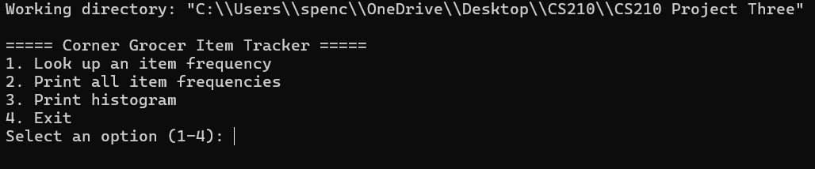
Figure 2. Main menu interface awaiting user selection.
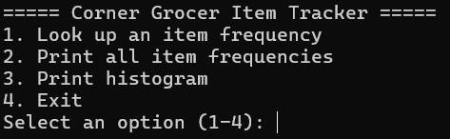
Figure 3. Item lookup showing returned purchase frequency.
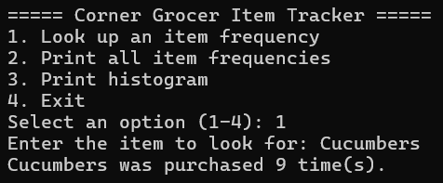

Figure 4. Full frequency report generated from input file.
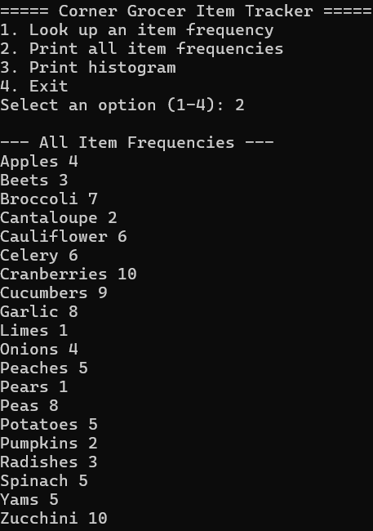

Figure 5. Histogram visualization representing purchase quantities.
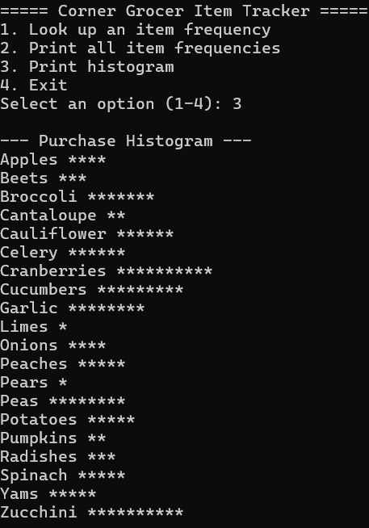
Figure 6. Automatically generated backup file (frequency.dat).
